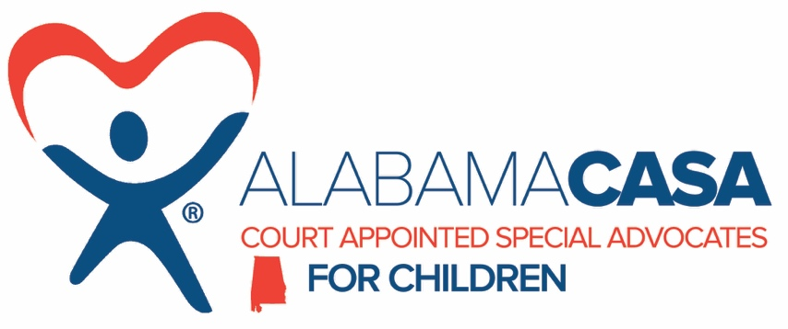

Status: Full-time
Location: Headquarters
Salary: $42,000

Reports to State Office staff

SUMMARY

This position is responsible for enhancing the awareness of Alabama CASA through recruitment, communication, marketing and stakeholder engagement implementation throughout the state. This role will focus on strategies to increase volunteer recruitment and retention, identify and secure funding; provide SME technical assistance; overall program compliance and development of new programs state-wide to include review of monthly reporting.

POSITION RESPONSIBILITIES

Strategic Planning
Liaison with state executive director and board of directors. Assist in the development of strategic and internal communication plans for operational readiness to include implementation and management.

Volunteer Recruitment & Retention
Create and manage the recruitment process, orientation, assessment and training of volunteers to effectively serve the programs within the state. Special emphasis will be placed on first time volunteer involvement and alignment with the mission. Policies and procedures for appropriate background assessments as well as annual volunteer recognition and appreciation.

Organizational Awareness
Develop communication strategies that promotes positive brand messaging. Produce and publish effective, persuasive media releases for state-wide dissemination and broadcast. Writes copy for printed marketing and conference materials, i.e. brochures, advertisements, flyers, social media and press kits. Coordinate special events and awareness campaigns to gain public involvement across multiple media platforms. Manages website maintenance, donor database and email campaigns on multiple projects.

Training & Development
Coordinate and facilitate trainings, workshops, roundtable and forum logistics including developing agendas, project plans, after action and production of reports. Assessment of organizational training needs to provide on-site and webinar learning options. Collect and share industry and best practices to leadership and program affiliates. Assist with program compliance, operational readiness and policies and procedures.

Grants & Fundraising
Create and implement a development strategic plan to increase funding sources. Develop and manage fundraising projects and activities. Cultivate relationships with stakeholders, businesses, foundations and other organizations to establish residual giving and additional revenue opportunities. Manage donor relations and prospects to activate new charitable giving. Ensure accurate audit trail is maintained for all stakeholder engagement and all contact/activities are recorded in a database. And, other duties as assigned.

QUALIFICATIONS

Significant management analysis experience with emphasis on marketing and business development. Proficient in Microsoft Office Suites including SharePoint and One Drive; various social media platforms and QuickBooks. Familiarity with using various CRM systems essential. Exceptional organizational abilities with project management. Minimum of 3-5 years of experience in grant writing and compliance. Proven ability to work and multi-task under pressure, respond quickly to changing situations in complex project environments, prepare responses/narrative quickly and clearly and use personal initiative. Good interpersonal and networking skills, highly articulate team player. Strong project management and people management skills. Bachelor’s Degree or the equivalent combination of education and experience.

WORK ENVIRONMENT
- Be a team-player and support co-workers.
- Business casual attire appropriate for office environment.
- Some travel required; proof of Alabama driver’s license and car insurance (required).

Candidates must successfully complete the local and federal criminal background checks, sex offender background checks, and Child Abuse Registry clearances.

EEO POLICY STATEMENT
The Alabama CASA Network provides equal employment opportunity for all employees and applicants for employment and does not unlawfully discriminate on the basis of age, sex (including pregnancy, childbirth or related medical conditions), color, race, national origin, ancestry, religion, marital status, family care status, physical disability, mental disability, medical condition, veteran status, sexual orientation, gender identity, or any other basis protected by federal and state laws.

How To Apply
If you would like to apply for the Advocate Coordinator position, please send a current resume and a relevant cover letter to support@alabamacasa.org. Due to the volume of resumes we receive, you may not receive an immediate reply. After 30 days, if you have not received a reply, you may email the above address to inquire.

