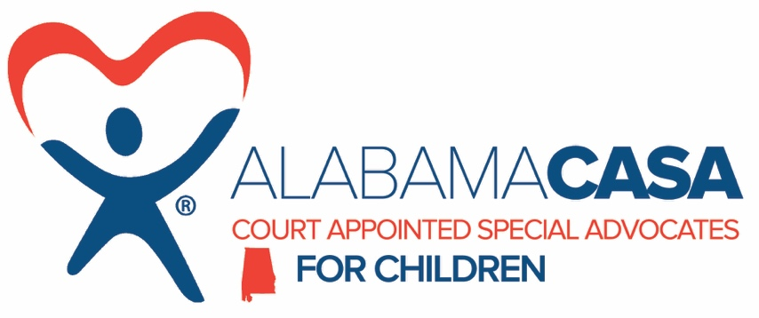

Status: Part-time
Location: Cullman County
Salary: $12,000

Reports to Local Program Manager and State Office Management

SUMMARY

This position is responsible for the supervision and management of program cases to ensure that abused and neglected children receive quality advocacy in court.

POSITION RESPONSIBILITIES

Volunteer Management
Assist with the recruitment, screening and training of new volunteers. Assist with reviewing new cases and assigning volunteers. Prepare and distribute assignment documentation. Oversee case development. Provide support to volunteers through regular communication. Consult with volunteers regarding reports. Attend court hearings when possible. Maintain case files on-site to include maintenance and data entry in Optima software. Assist with the completion of monthly reporting and implementation of a volunteer in-service training program. Prepare volunteer evaluations.
Assist in the preparation of volunteer appreciation events.

Volunteer Liaison
Keep Program Manager informed of volunteer issues. Keep the court informed of volunteer issues.

Community Awareness
Maintain effective relationships through personal contact and written communication with other professional and social service organizations, funding groups and charitable organizations.
Interpret the mission of CASA to the public. Serve as a spokesperson with the media when required.

Administrative
Attend staff meetings. Assist with revisions to the volunteer job description when needed. Attend conferences, seminars and meetings as requested by the Program Director and Alabama CASA Network. Sit on hiring committees when requested. Participate in fundraising activities when requested. Assist in maintaining the case file database. Compile statistical information as required. Some travel required; and other duties as assigned.

QUALIFICATIONS

Experience in a social service-related field. The ability to communicate with and empower volunteers and to be effective in their roles. Able to work cooperatively with different types of personalities. Knowledge and understanding of issues and dynamics within families in crisis relating to child abuse and neglect. Commitment to the program’s mission, goals and standards.

WORK ENVIRONMENT
- Be a team-player and support co-workers.
- Business casual attire appropriate for office environment.
- Some travel required; proof of Alabama driver’s license and car insurance (required).

Candidates must successfully complete the local and federal criminal background checks, sex offender background checks, and Child Abuse Registry clearances.

EEO POLICY STATEMENT
The Alabama CASA Network provides equal employment opportunity for all employees and applicants for employment and does not unlawfully discriminate on the basis of age, sex (including pregnancy, childbirth or related medical conditions), color, race, national origin, ancestry, religion, marital status, family care status, physical disability, mental disability, medical condition, veteran status, sexual orientation, gender identity, or any other basis protected by federal and state laws.

How To Apply
If you would like to apply for the position, please send a current resume and a relevant cover letter to cullmancountycasa@msn.com. Due to the volume of resumes we receive, you may not receive an immediate reply. After 30 days, if you have not received a reply, you may email the above address to inquire.

