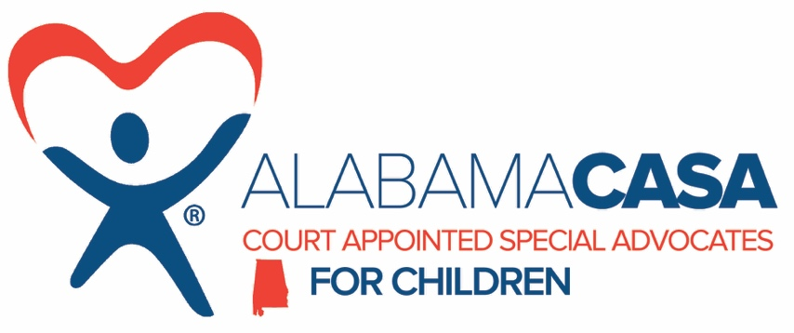

Status: Full-time
Location: Tri-County (St. Clair, Talladega, Calhoun)
Salary: $30,000-32,000 (dependent on credentials)

Reports to Local Program Manager

SUMMARY

This position is responsible for the ongoing supervision and management of program cases to ensure that abused and neglected children receive quality advocacy in court.

QUALIFICATIONS

Bachelor’s degree preferred, in a social service-related field, or the equivalent combination of education and experience. Must have advanced writing skills and grammatical abilities. (May be required to complete writing sample during hiring process). Ability to interact with, inspire, and empower volunteers effectively. Consistently able to work with different types of personalities. Positive, uplifting attitude with ability to adapt. Knowledge and understanding of issues and dynamics within families in crisis relating to child abuse and neglect. Long term commitment to the program’s mission, goals, and standards. Must have the ability to be “on call” as needed for volunteer support. Post 5 PM and weekend work may be required. May be required to work more than 40 hours a week, as needed.

POSITION RESPONSIBILITIES

- Volunteer Management
Assist with the recruitment, screening and training of new volunteers. Assist with reviewing new cases and assigning volunteers. Prepare and distribute assignment documentation. Oversee case development. Provide support to volunteers through regular communication. Consult with volunteers regarding reports. Attend court hearings when possible. Maintain case files on-site to include maintenance and data entry in Optima software. Assist with the completion of monthly reporting and implementation of a volunteer in-service training program. Prepare volunteer evaluations. Prepare written court reports. Edit written volunteer reports. Grammatically proficient in written and spoken word. Assist in the preparation of volunteer appreciation events.

- Volunteer Liaison
Keep Program Director informed of volunteer issues. Keep the court informed of volunteer issues.

- Community Awareness

Maintain effective relationships through personal contact and written communication with other professional and social service organizations, funding groups and charitable organizations.
Interpret the mission of CASA to the public. Serve as a spokesperson with the media when required.

- Administrative
Attend staff meetings. Assist with revisions to the volunteer job description when needed. Attend conferences, seminars and meetings as requested by the Program Director. Sit on hiring committees when requested. Participate in fundraising activities when requested. Assist in maintaining the case file database. Compile statistical information as required. Travel and reliable transportation are required; and other duties as assigned.

WORK ENVIRONMENT
- Be a team-player and support co-workers.
- Business casual attire appropriate for office environment.
- Travel required; proof of Alabama driver’s license and car insurance (required).

Candidates must successfully complete the local and federal criminal background checks, sex offender background checks, and Child Abuse Registry clearances.

EEO POLICY STATEMENT
The Alabama CASA Network provides equal employment opportunity for all employees and applicants for employment and does not unlawfully discriminate on the basis of age, sex (including pregnancy, childbirth or related medical conditions), color, race, national origin, ancestry, religion, marital status, family care status, physical disability, mental disability, medical condition, veteran status, sexual orientation, gender identity, or any other basis protected by federal and state laws.

How To Apply
If you would like to apply for the Advocate Coordinator position, please send a current resume and a relevant cover letter to support@alabamacasa.org. Due to the volume of resumes we receive, you may not receive an immediate reply. After 30 days, if you have not received a reply, you may email the above address to inquire.

